MATH221 – Mathematics for Computer Science – Autumn 2018

Assignment One Answers

Question 1:



Question 2. (1)



|  |  |  |  |  |  |  |
| --- | --- | --- | --- | --- | --- | --- |
|  |  |  |  |  |  |  |
|  |  |  |  |  |  |  |
|  |  |  |  |  |  |  |
|  |  |  |  |  |  |  |
|  |  |  |  |  |  |  |



Question 3.



|  |  |  |  |  |  |
| --- | --- | --- | --- | --- | --- |
|  | **1** | **2** | **3** | **4** | **5** |
| **1** |  |  |  |  |  |
| **2** |  |  |  |  |  |
| **3** |  |  |  |  |  |
| **4** |  |  |  |  |  |
| **5** |  |  |  |  |  |

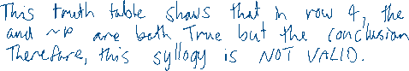

Question 4.

